Bringing Forward God’s Tithes and Our Gifts
*Doxology #95 Praise God from whom all blessings flow; praise him, all Creatures here below; praise him above, ye heavenly host; praise Father, Son, and Holy Ghost. Amen.
*Prayer of Thanksgiving
Sharing of Joys and Concerns
The Lord’s Prayer

Our Father, who art in heaven, hallowed be thy name. Thy kingdom come, Thy will be done on earth as it is in heaven. Give us this day our daily bread and forgive us our trespasses, as we forgive those who trespass against us. And lead us not into temptation, but deliver us from evil. For thine is the kingdom, and the power, and the glory, forever. Amen.
*Singing Our Faith #2032 (TFWS) “My Life Is in You, Lord”
*Blessing and Dismissal
*Postlude

Scatter to Serve God & Neighbor

Welcome to all! We gather to praise God for the innumerable blessings given to us and to grow deeper in the Spirit. Joyfully, let us lift our hearts to God.

DIRECTORY OF CHESTNUT HILL UNITED METHODIST CHURCH
Adam J. White | Minister
Sharon Mayhew | Director of Music
Monica Campbell | Administrative Assistant
Judy Martin | Bookkeeper
Judy Robertson  Elizabeth Nichols | Lay Leader  Missionary in Henry County


C hestnut Hill
United Methodist Church

Making disciples of Jesus Christ
for the transformation of the world.
You are welcome at Chestnut Hill UMC.

4660 Fort Avenue ~ Lynchburg, Virginia 24502
Church: 434-239-8423
Minister’s Cell: 434-944-7723, Minister’s Email: awhite@ves.org
Email: chestnuthillumc@comcast.net
On the Web at chestnuthillumc.net
Find us on Facebook: Chestnut Hill United Methodist Church

Chestnut Hill United Methodist Church

10:30 a.m. ~ July 26, 2026 ~ Ninth Sunday after Pentecost
Our ministry vision for the Virginia Annual Conference is “to be
disciples of Jesus Christ who are lifelong learners, who influence others to serve.”

Welcome! Join us in worshiping God!
Prelude
Welcome and Ministry Announcements
Welcome in the name of Christ our Lord. Please register your attendance, printing your name, address, phone, and email, on the attendance pad provided on your pew. Thank you for silencing cell phones as we gather to worship God.
Invocation
*Greeting
God's great love is so amazing!
See — a shepherd with his flocks!
Ninety-nine are safely grazing;
one is lost among the rocks.
That good shepherd goes and searches
till he finds the one astray.
So God says to fill our churches
with the ones who've lost their way.
God in love is always seeking!
See — a woman with her broom!
For a single coin she's sweeping
every corner of the room.
When it's found she calls each neighbor,
telling friends from all around.
So God says to search and labor
till God's precious ones are found.

God keeps waiting, searching, yearning!
See — a father's heartfelt joy!
Thankful for his son's returning,
he runs out to greet his boy.
To the angry older brother,
hear the father's patient call.
So God says to love each other,
for in Christ, God loves us all.
*Singing Our Faith #480 “O Love That Wilt Not Let Me Go”

Opening Prayer
O God, the protector of all who trust in you, without whom nothing is strong, nothing is holy: Increase and multiply upon us your mercy; that, with you as our ruler and guide, we may so pass through things temporal, that we lose not the things eternal; through Jesus Christ our Lord, who lives and reigns with you and the Holy Spirit, one God, for ever and ever. Amen.

Anthem “God Will Take Care of You”

Greeting Friends and Neighbors

Prayer of Illumination
O God, in you are hidden all the treasures of wisdom and knowledge. Open our hearts to receive the truth of your Word. Help us understand and freely choose the way of your wisdom; in Christ’s way we pray. Amen.
Scripture Lessons: Matthew 13:31-33, 44-52 and Luke 15:8-10
The Word of God for the people of God.

Thanks be to God.
Singing Our Faith #2158 (TFWS) “Just a Closer Walk with Thee”
The Good News “Hiding in Plain Sight”

**Calendar **
Wednesday, 7/29 | 6:00 p.m. | Camp Meadowlark Line Dancing
Thursday, 7/30  Thru Saturday, 8/1 |  | Church Offices Closed for maintenance on floors.
** Looking Ahead on the Calendar **
Sunday, 8/9 | 10:00 a.m. | Choir


In Memoriam

Robbie Duff Perrow

May 23, 1932 – July 20, 2026

Chestnut Hill United Methodist Church extends Christian love and sympathy to the family of Robbie Duff Perrow and especially to her brother, Clarence Duff, and nephews, Michael Stinnett and Harry Stinnett.
For the Grocery Cart:
July ~ All Canned Goods (with or without Pop-tops.)

Birthdays: July 30-Ann Robbins, August 1-Betty Taylor,
2-Greyson Glass, 4-Colby Takacs, 5-Braelyn Underwood

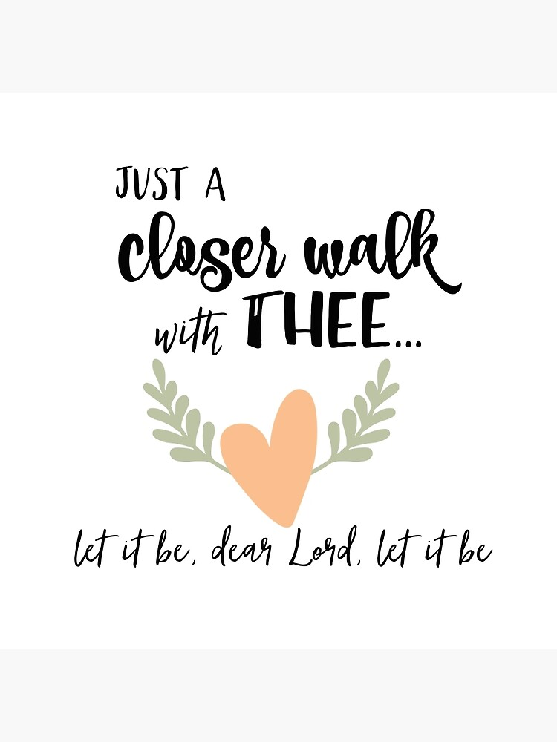

**Calendar **
Wednesday, 7/29 | 6:00 p.m. | Camp Meadowlark Line Dancing
Thursday, 7/30  Thru Saturday, 8/1 |  | Church Offices Closed for maintenance on floors.
** Looking Ahead on the Calendar **
Sunday, 8/9 | 10:00 a.m. | Choir

In Memoriam

Robbie Duff Perrow

May 23, 1932 – July 20, 2026

Chestnut Hill United Methodist Church extends Christian love and sympathy to the family of Robbie Duff Perrow and especially to her brother, Clarence Duff, and nephews, Michael Stinnett and Harry Stinnett.
For the Grocery Cart:
July ~ All Canned Goods (with or without Pop-tops.)
Birthdays: July 30-Ann Robbins, August 1-Betty Taylor,
2-Greyson Glass, 4-Colby Takacs, 5-Braelyn Underwood

